MODULE 4 : INFORMATICA INTELLIGENT CLOUD SERVICES(IICS)

1. Making connection to SQL Server data source.

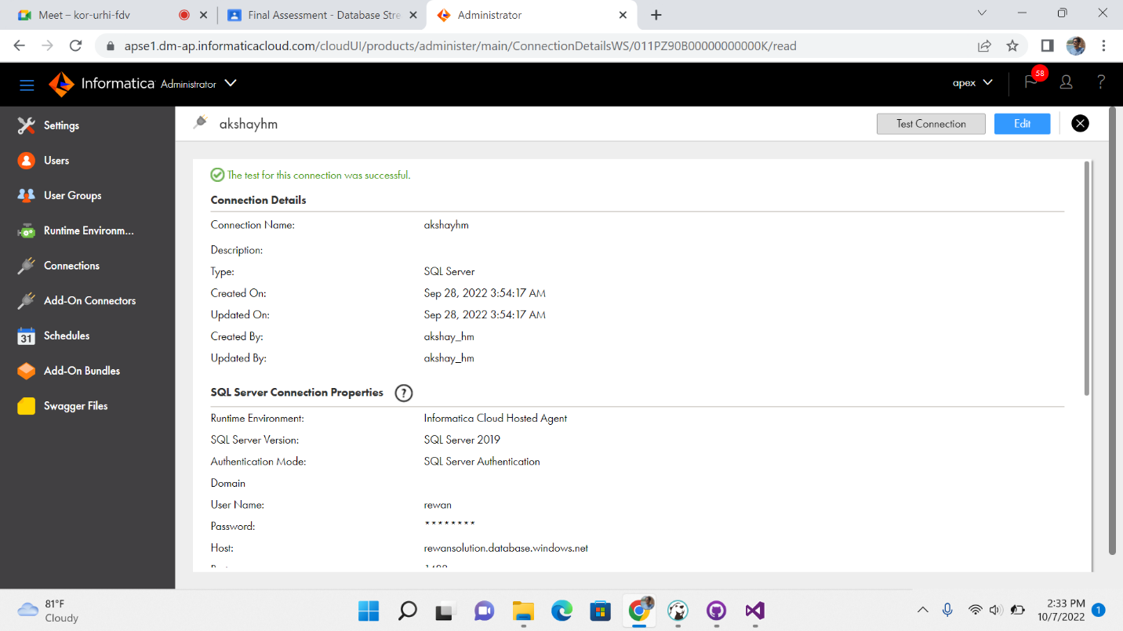

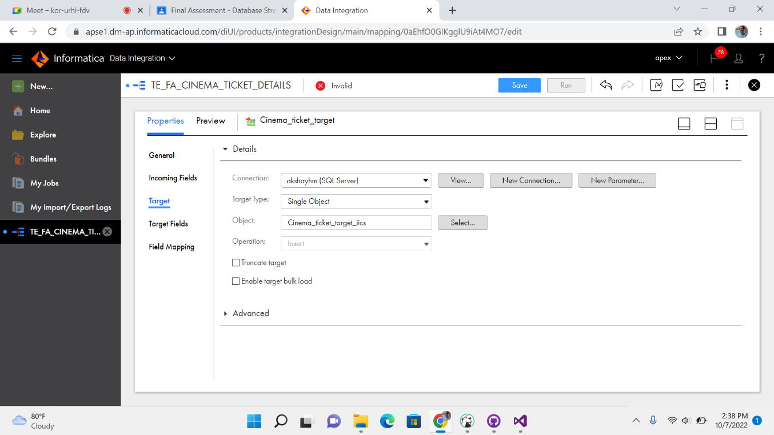

Taking the source and renaming it and connecting to SQL Server and selecting the table .

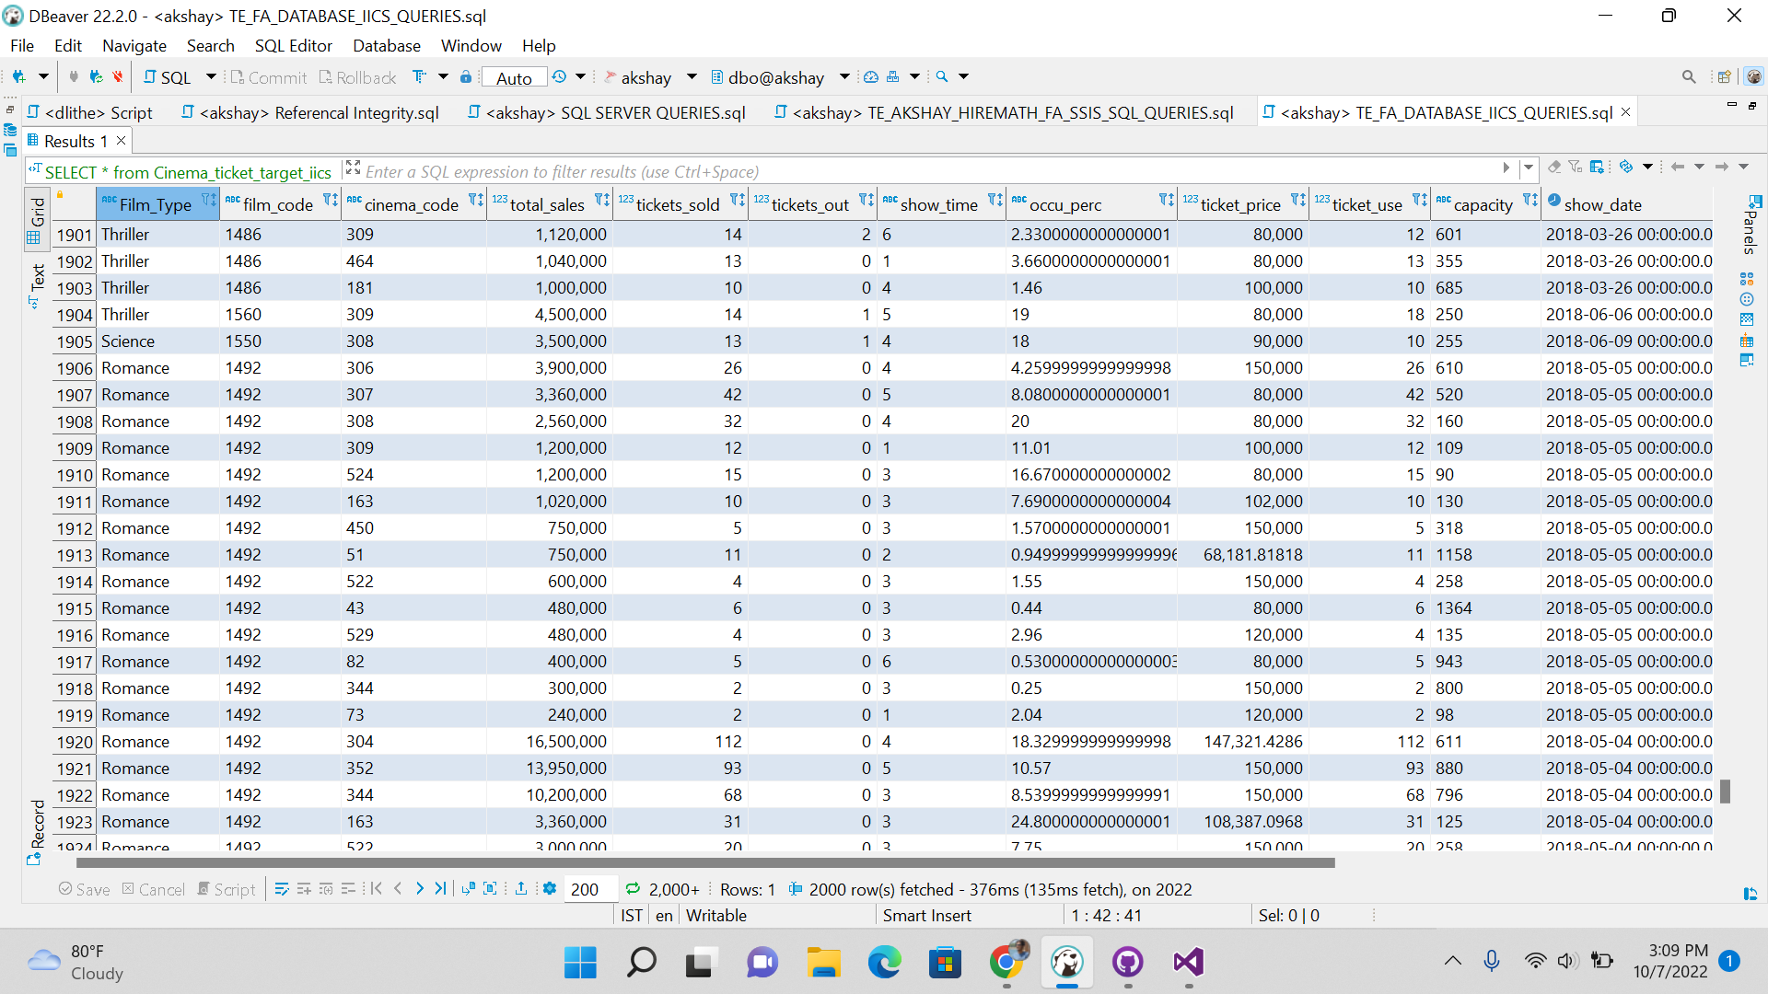

2. Extracting the data which is in the source table of SQL Server.

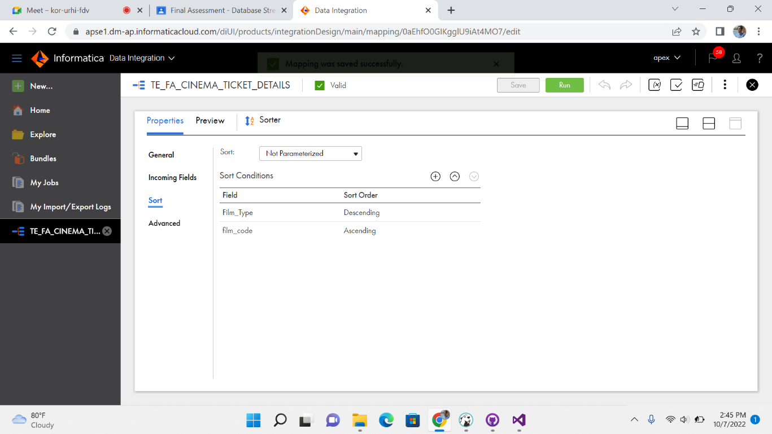

3. Transforming the data using the sorter transformation and sorting the Film Type and film code

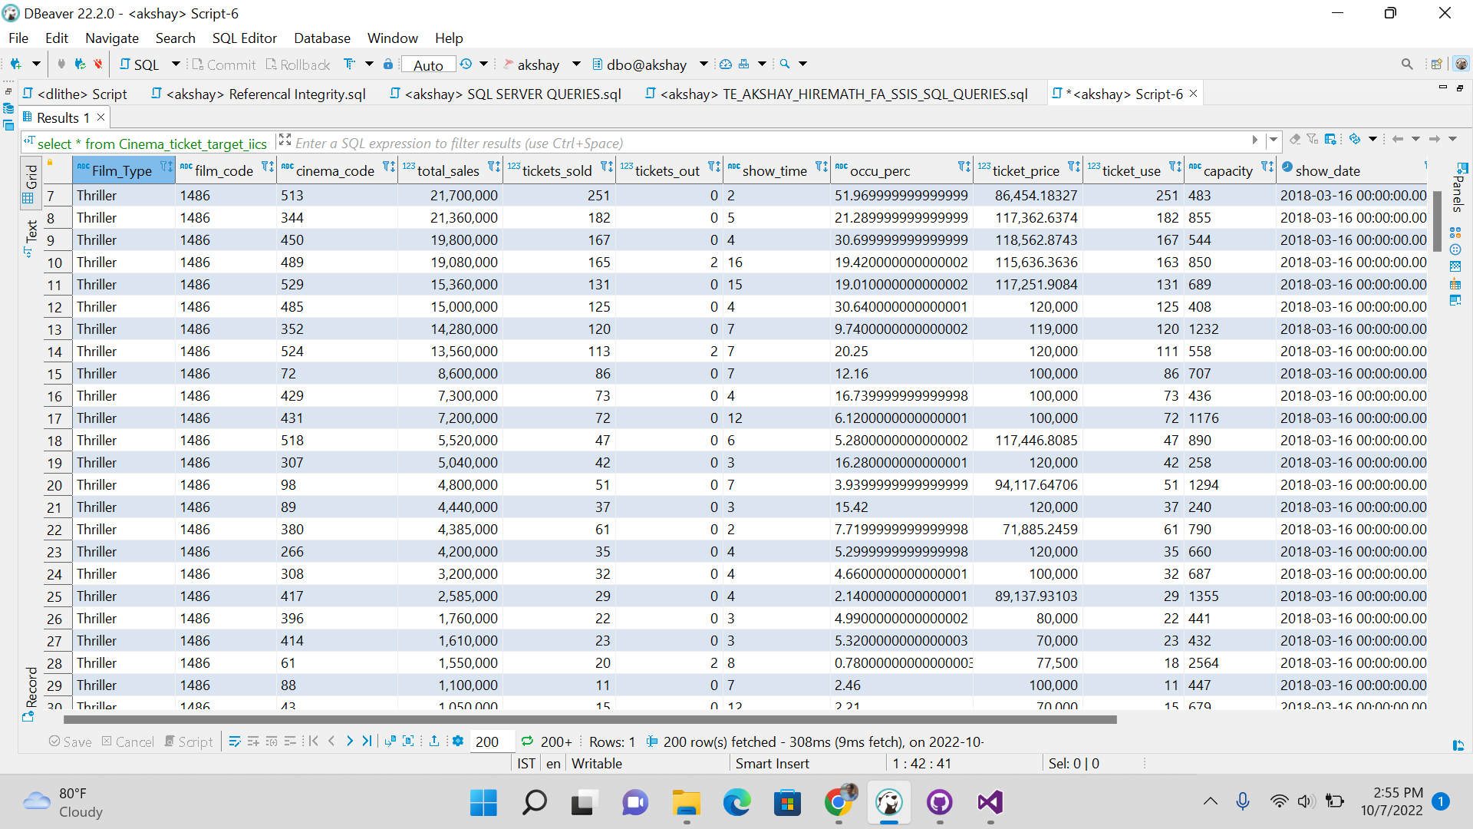

4.Loading the data in the target of the SQL Server is in the below , and above is how data loaded to target.

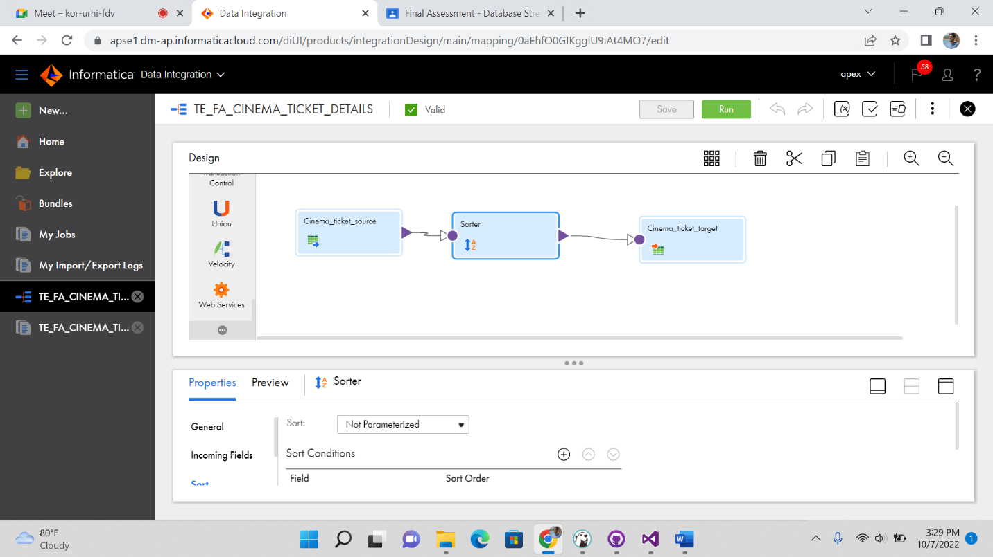

This is the pictorial representation of extracting the data from source and transforming in sorter and loading in the target in IICS.

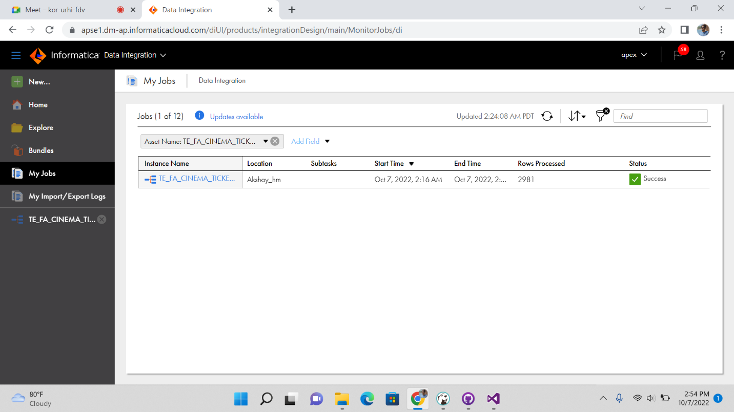

This is how it shows if the data is loaded in target SQL Server.

5.SCD TYPE 1: In Slowly changing dimension type 1 if we update in the source and it will get updated in destination.

Below is the result after updating the source and it will ge updated .In the SCD Type 1 changing attribute so that data gets updated.

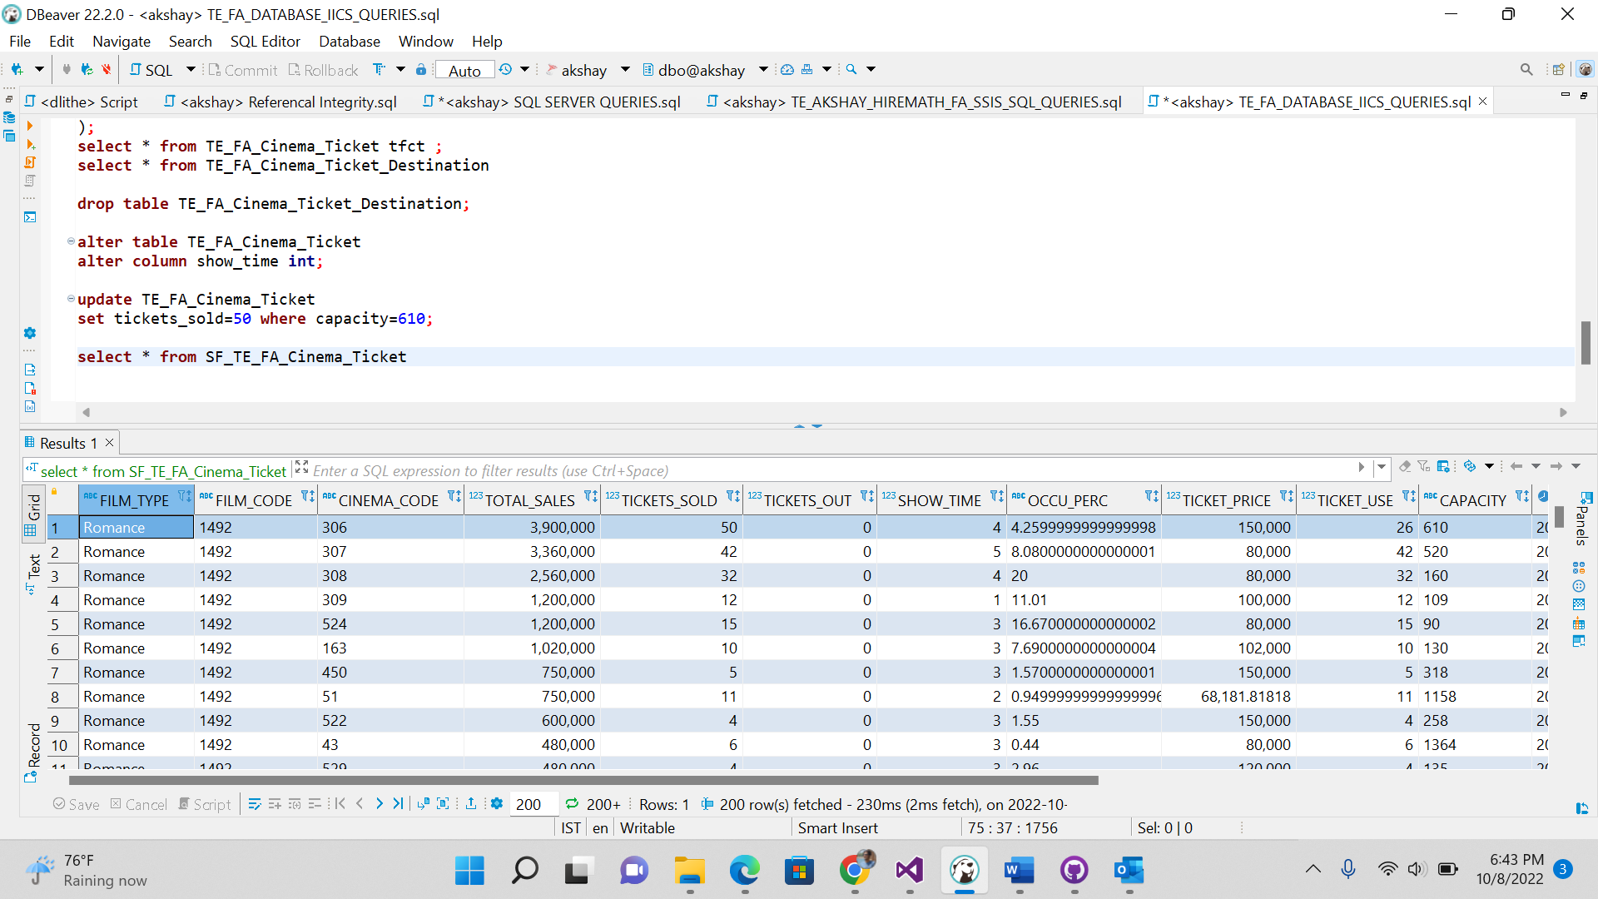

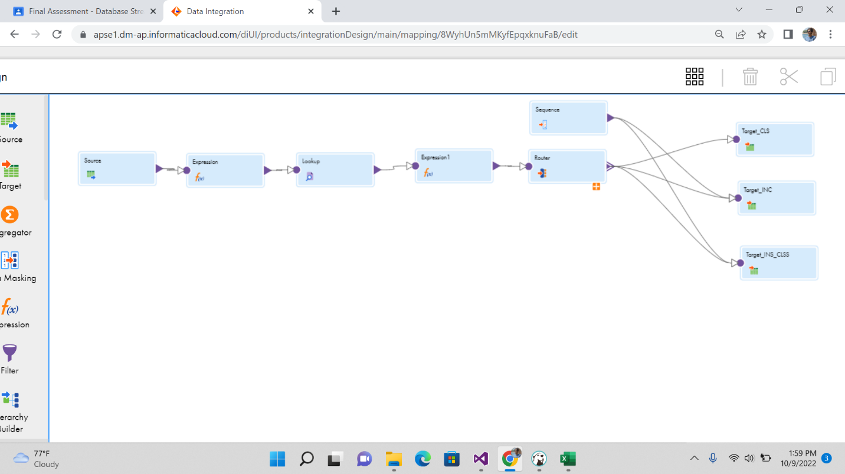

SCD Type 2: This is the SCD Type 2 in which the slowly changing dimension Type 2 in which data gets updated as new row and historical data it will be in destination.

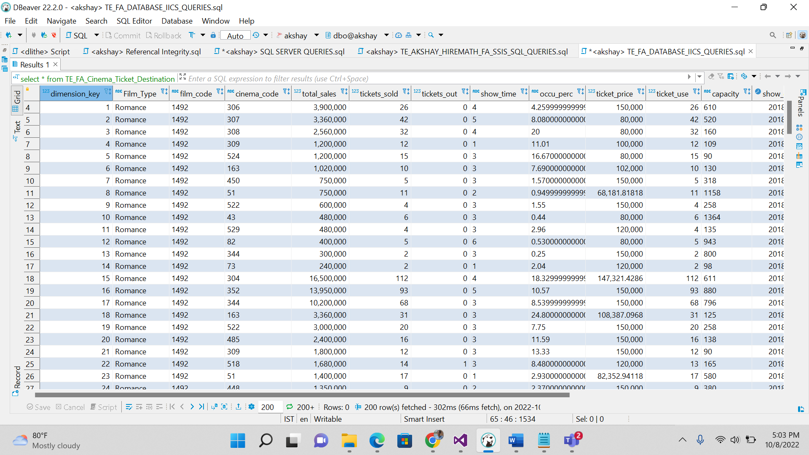

The updated rows will get changed & updated in the destination .

6.Aggregate table created in which the maximum of Provider zip code is done and it will show in destination maximum. And below is the aggregate table for the sum of the aggregation performing through aggregate transformation.

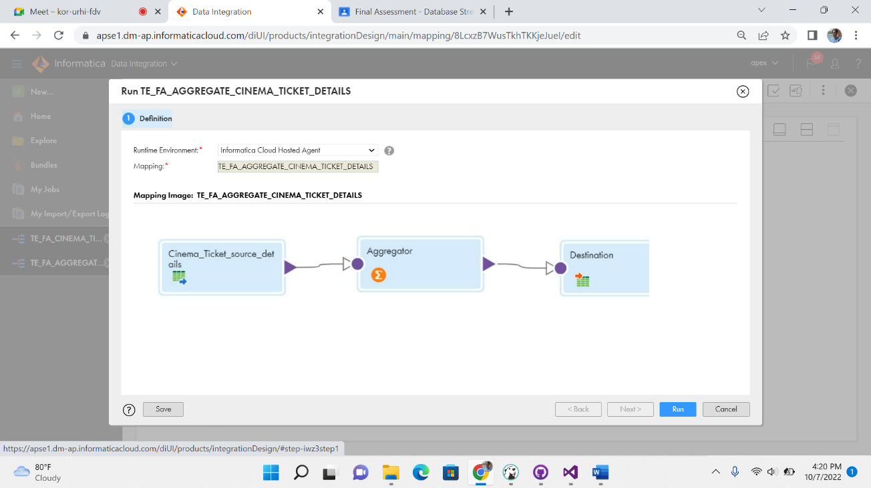

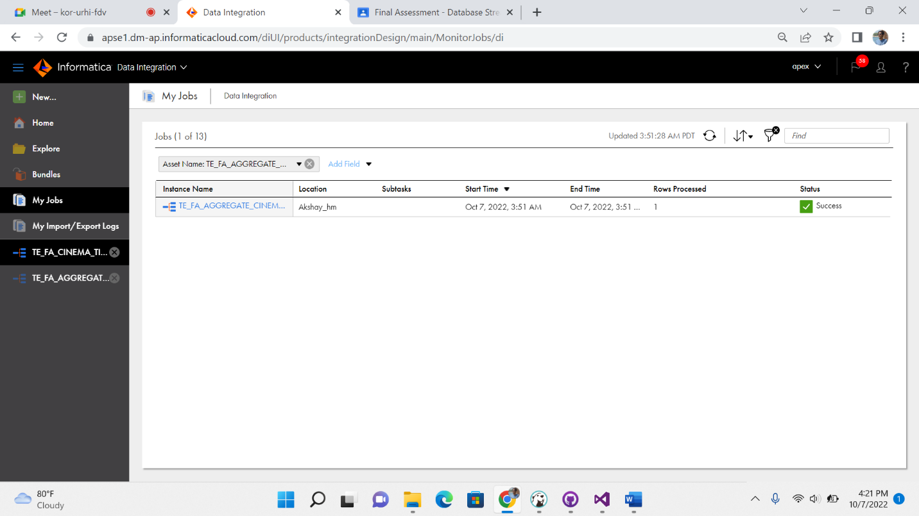

In IICS this is how it shows if it is success in the mapping task.

7.Data Replication Task: In data replication task as in single object can be replicated.

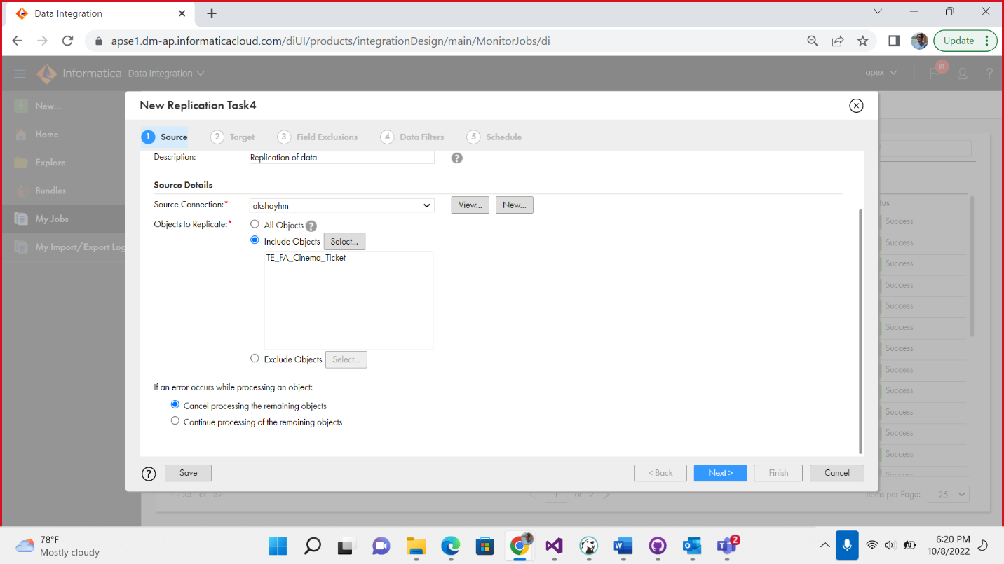

In these single object is replicated.

This is how it shows if we get success of data replication happens.

Email can be given it will notify if success , failure or warning .

Data replication of complete DB can also be done in IICS.

Step1 : Selecting the source of which DB data to be replicated.

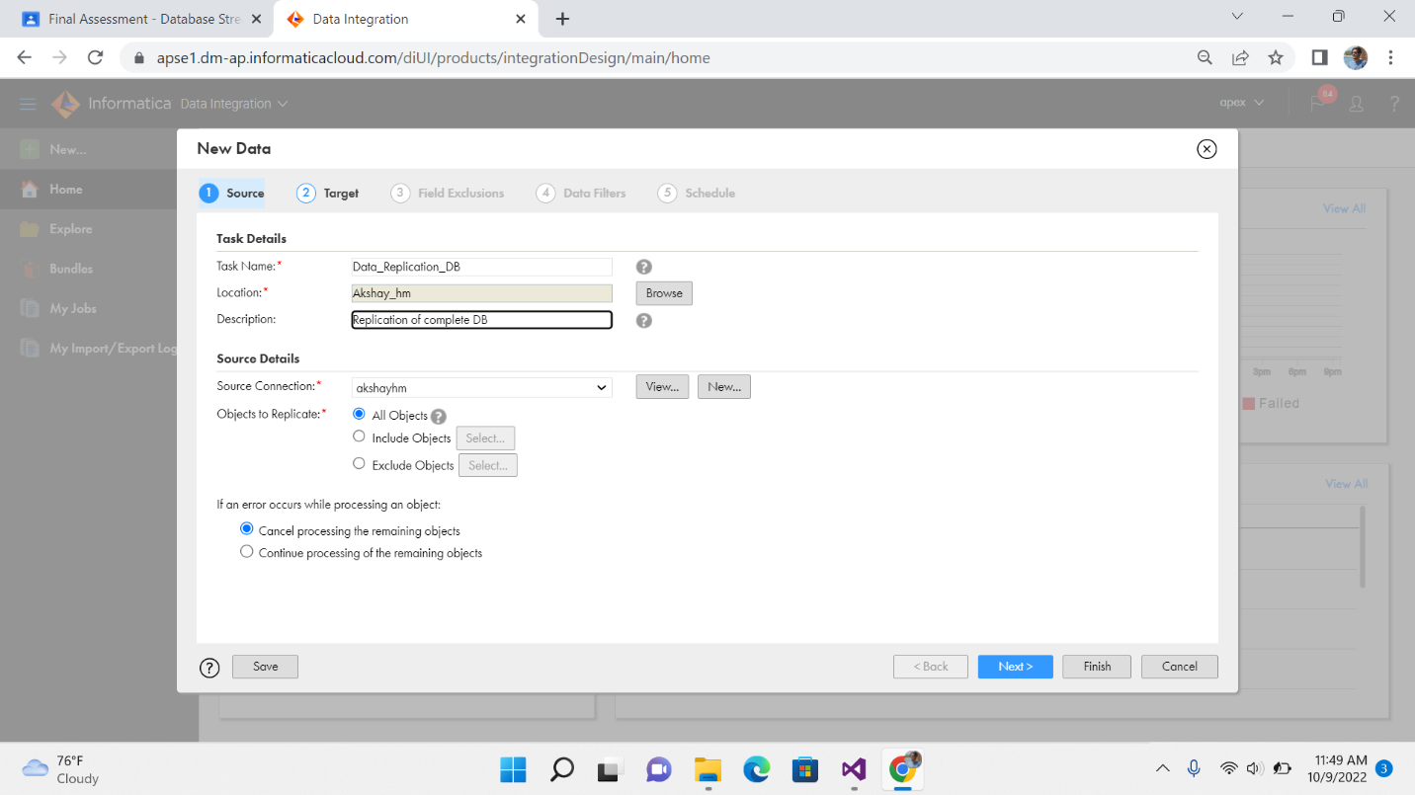This is the source in which we give name and select the SQL sever .

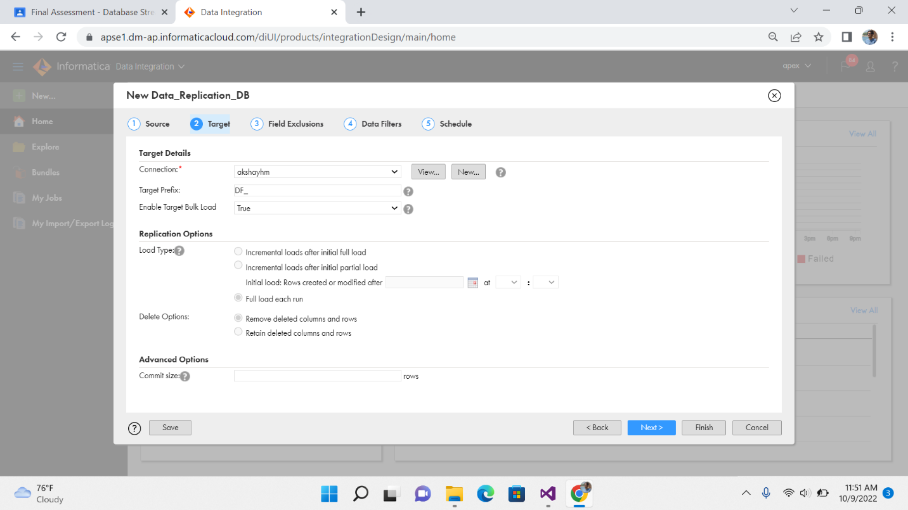

This is the target SQL DB in which data to be replicated

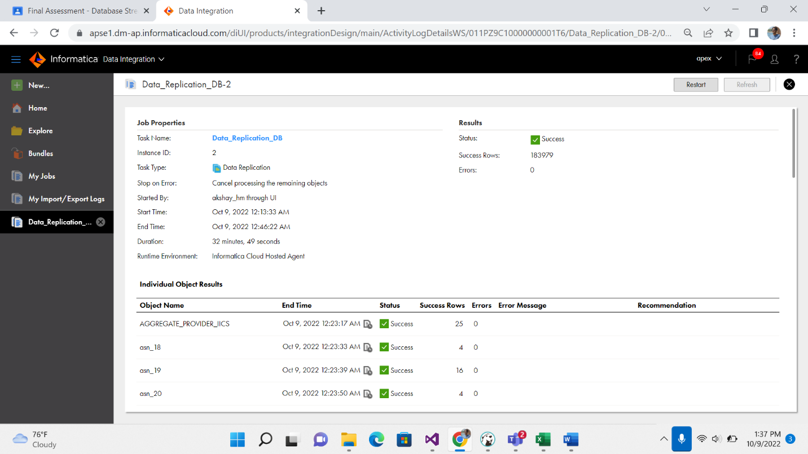

This is the success of complete data replication of DB.

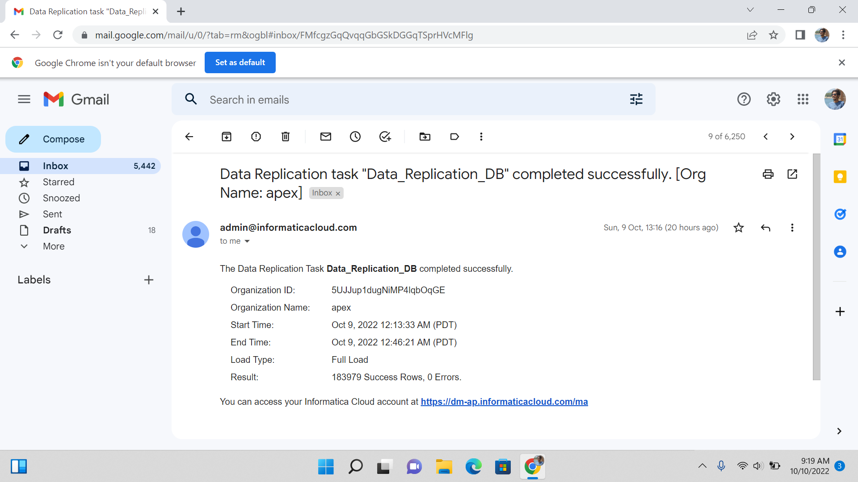

The email will be send like this if success and full load of DB.